Hunting In Memory (Lab 1)

LAB 7.1

Scenario
The organization you work for is asking you to perform memory threat hunting on a randomly selected machine. The IT Security manager tasked you specifically with looking for anomalous connections and memory injections.
A memory image has already been created and is waiting for you!

Goals
The learning objective of this lab is to get more familiar and comfortable with Volatility.

What you will learn
You will learn how to utilize a memory dump to confirm a compromise.

Recommended tools
- Volatility
- Strings
- Base64

Tasks

Task 1. Are there any hidden processes?
The machine's memory image file can be found in the /root/ directory.
Begin by identifying the image profile that is required by Volatility before it can parse the memory file.
It is very common for rootkits to hide the presence of a process from tools such as Task Manager on a live Windows machine. However, with the use of Volatility's psscan/psxview plugins, we can identify anomalies that may exist.

Task 2. Hunt for suspicious network connections?
Use Volatility's netscan plugin and review the output for anything that looks suspicious.

Task 3. Hunt for process injection
Use Volatility's malfind plugin and review the output for anything that looks suspicious. Be aware of false-positives, as certain processes perform injection as part of their regular operation.

Task 4. What can we conclude?
Based on the information discovered, what can you conclude and how can you extract additional information that will conclude your hunt and be useful to other teams such as Incident Responders.

SOLUTIONS
Below, you can find solutions for each task. Remember though, that you can follow your own strategy, which may be different from the one explained in the following lab.

Task 1. Are there any hidden processes?
To begin with, we can execute Volatility's imageinfo plugin, to get an idea of the profile of the machine. Let's do so by navigating to /root/ and executing the command below.
vol.py -f /root/Memory.vmem imageinfo
In the output, Volatility displays the following:
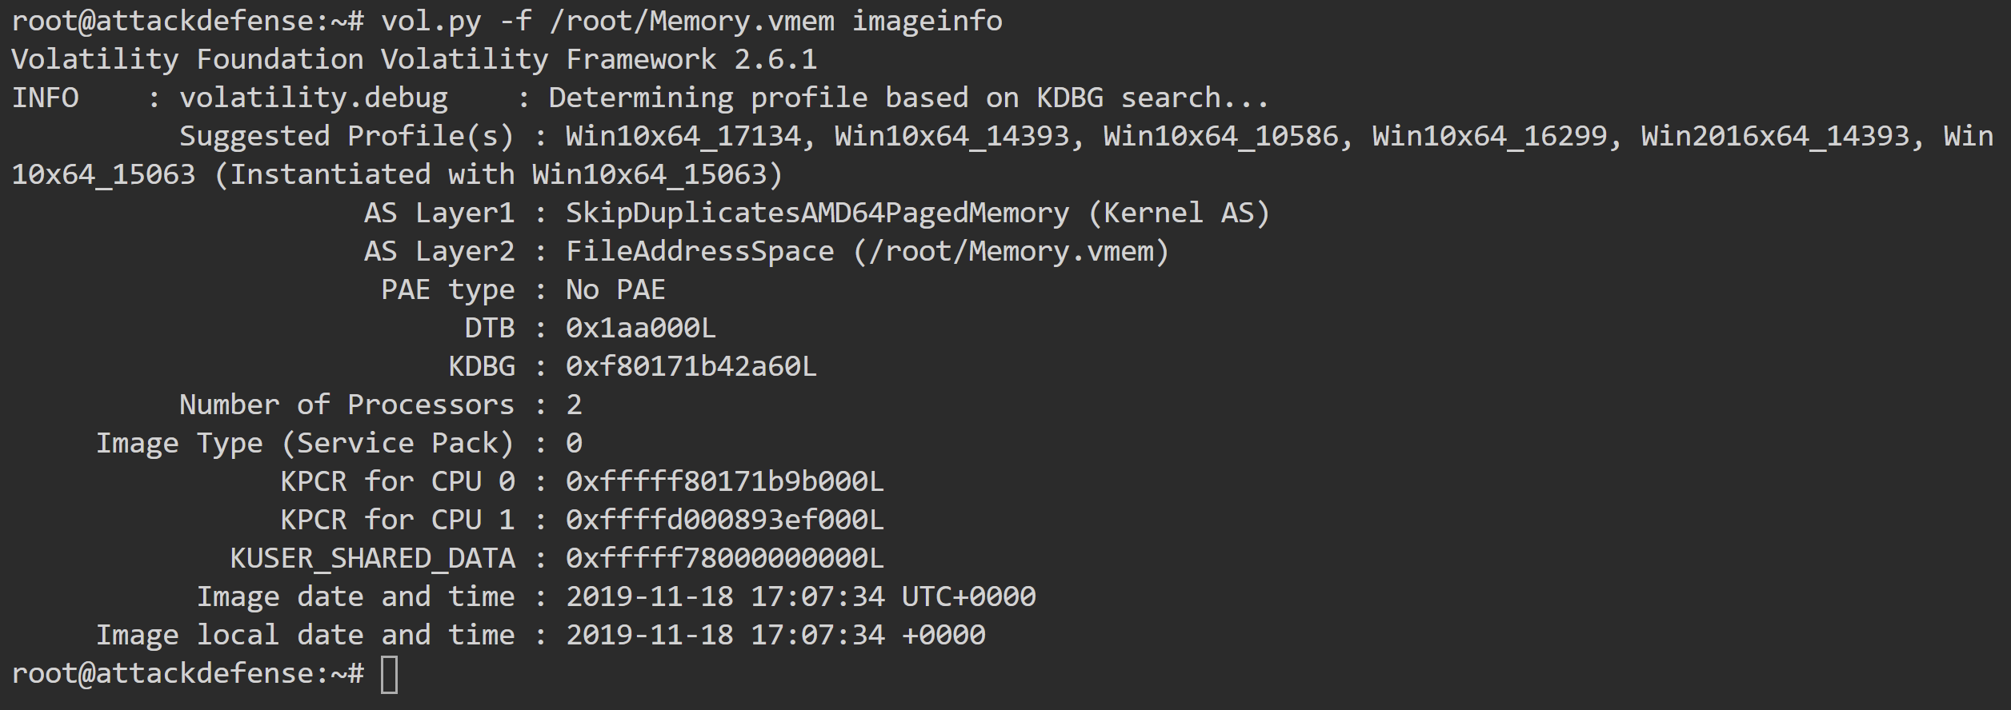
Unfortunately, Volatility did not recognize the profile immediately, after some trial and error approach, it appears that the correct one is "Win10x64_10586", which is one of the possible profiles that Volatility suggested.
Armed with the profile, we proceed further to look at the output of psxview, directly jumping into looking for anomalies related to process hiding. The output of it would look similar as on the image below, where we have cropped the image for brevity:
vol.py -f /root/Memory.vmem --profile=Win10x64_10586 psxview

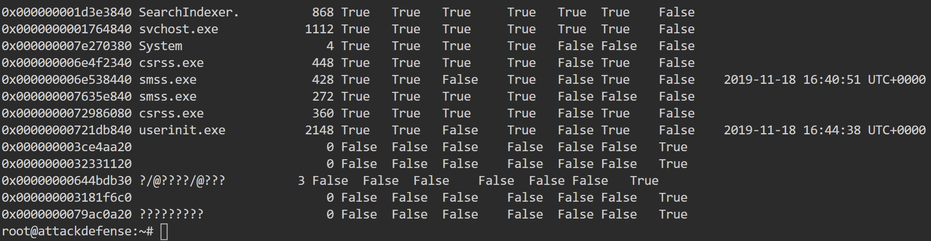
Although it appears that there are processes which seem not detected by 6 out of 7 of the techniques that psxview uses, they are just false positives. It is likely that the EPROCESS memory structure has persisted from a previous reboot, however they are lacking many of the attributes, that's why Volatility fails to parse them properly.
No running processes are hidden.

Task 2. Hunt for suspicious network connections
To look at network connections, we'll use Volatility's netscan plugin. After running it, we'll notice that multiple PowerShell instances have been making (they are now closed but still preserved in memory!) connections to port 80. Remember, we are generally interested in any process that makes connections to port 80 and 443, which is not a browser. Here is the output from the plugin, specifically filtering out the connections from PowerShell:
vol.py -f /root/Memory.vmem --profile=Win10x64_10586 netscan | grep -E 'Pid|powershell.exe'
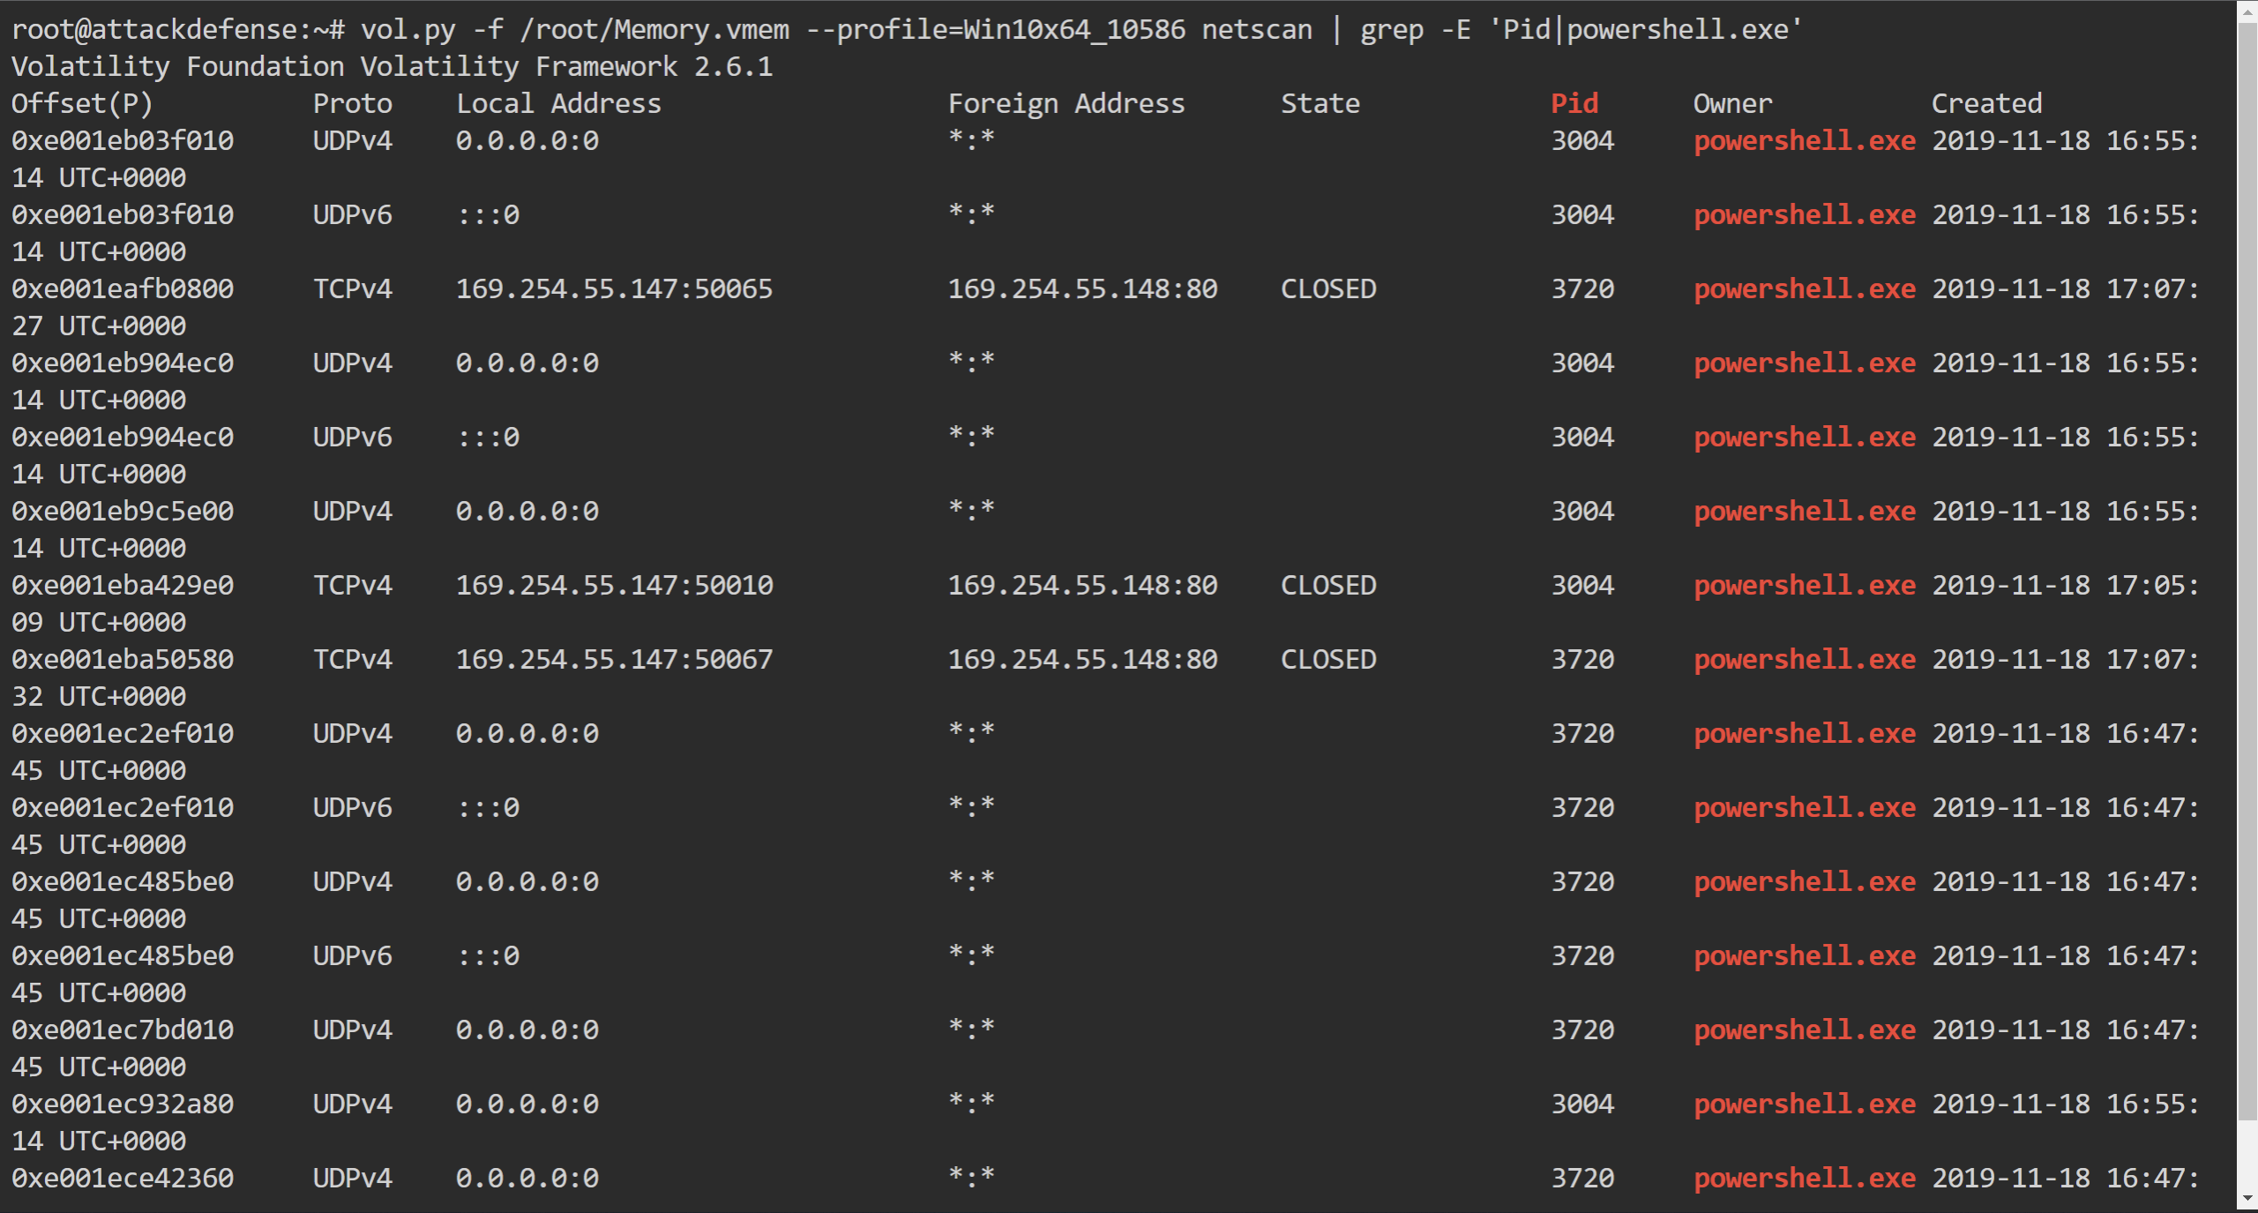
Suspicious connections have originated from powershell.exe instances, all of which have connected to the same remote IP address on port 80.

Task 3. Hunt for process injection
When hunting for injection on a memory dump, Volatility's malfind plugin is the go to approach. Running the plugin returns that injection was detected in the following processes:
vol.py -f /root/Memory.vmem --profile=Win10x64_10586 malfind
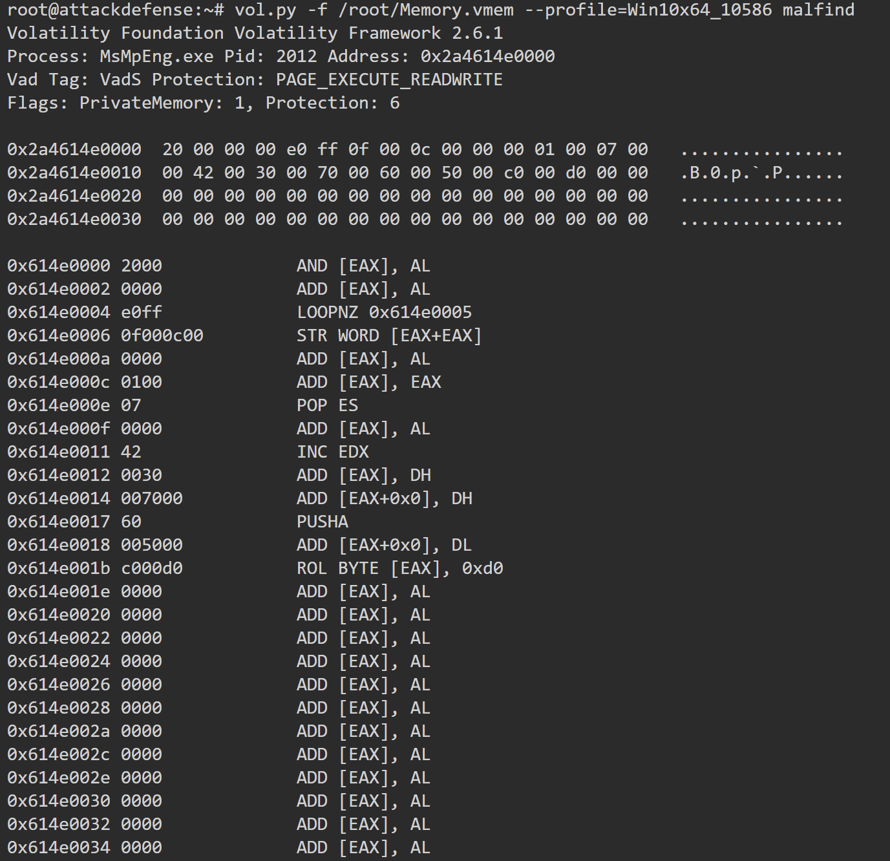
- MsMpEng.exe (PID 2012) -- 2 injected memory regions
- Powershell.exe (PID 3720) -- 5 injected memory regions
- SearchUI.exe (PID 4784) -- 1 injected memory region
- Powershell.exe (PID 4740) -- 4 injected memory regions
- Powershell.exe (PID 3004) - 5 injected memory regions
It is normal for some processes to show signs of injection due to the way they operate, where in this case MsMpEng.exe and SearchUI.exe are false positives. PowerShell on the other hand should not have any signs of injection under normal operations. None of the injected memory regions begin with the "MZ" header though, which may indicate an injection of Windows executable file. Nonetheless, there may be multiple reasons for that, ranging from a tool that overwrites the injected memory regions as an anti-forensic technique after execution to prevent analysts from obtaining the injected code, to simply injection of raw shellcode instead of a whole executable.

Task 4. What can we conclude?
PowerShell processes have had suspicious internet connections and exhibit signs of injections. PowerShell's scripts are often still stored in the memory of a machine and using the "strings" utility, we can attempt to find certain patterns. For example, simply checking for "Invoke-" results in a wealth of information:
strings /root/Memory.vmem | grep "Invoke-"
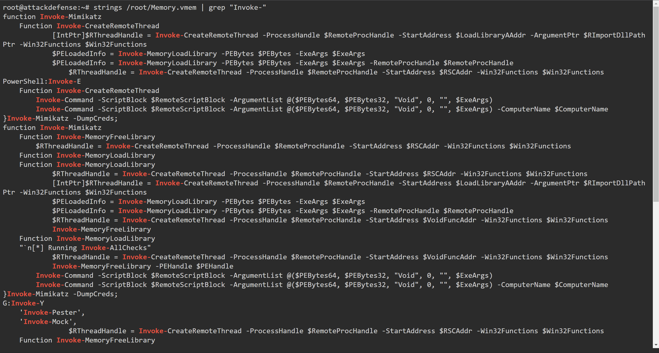
From the very first lines, we can conclude that a compromise has occurred due to the presence of the string "Invoke-Mimikatz".
Another search would be to simply look for "powershell", the output of which presents us again with a wealth of information, such as the following:
strings /root/Memory.vmem | grep "powershell" > output
vim output
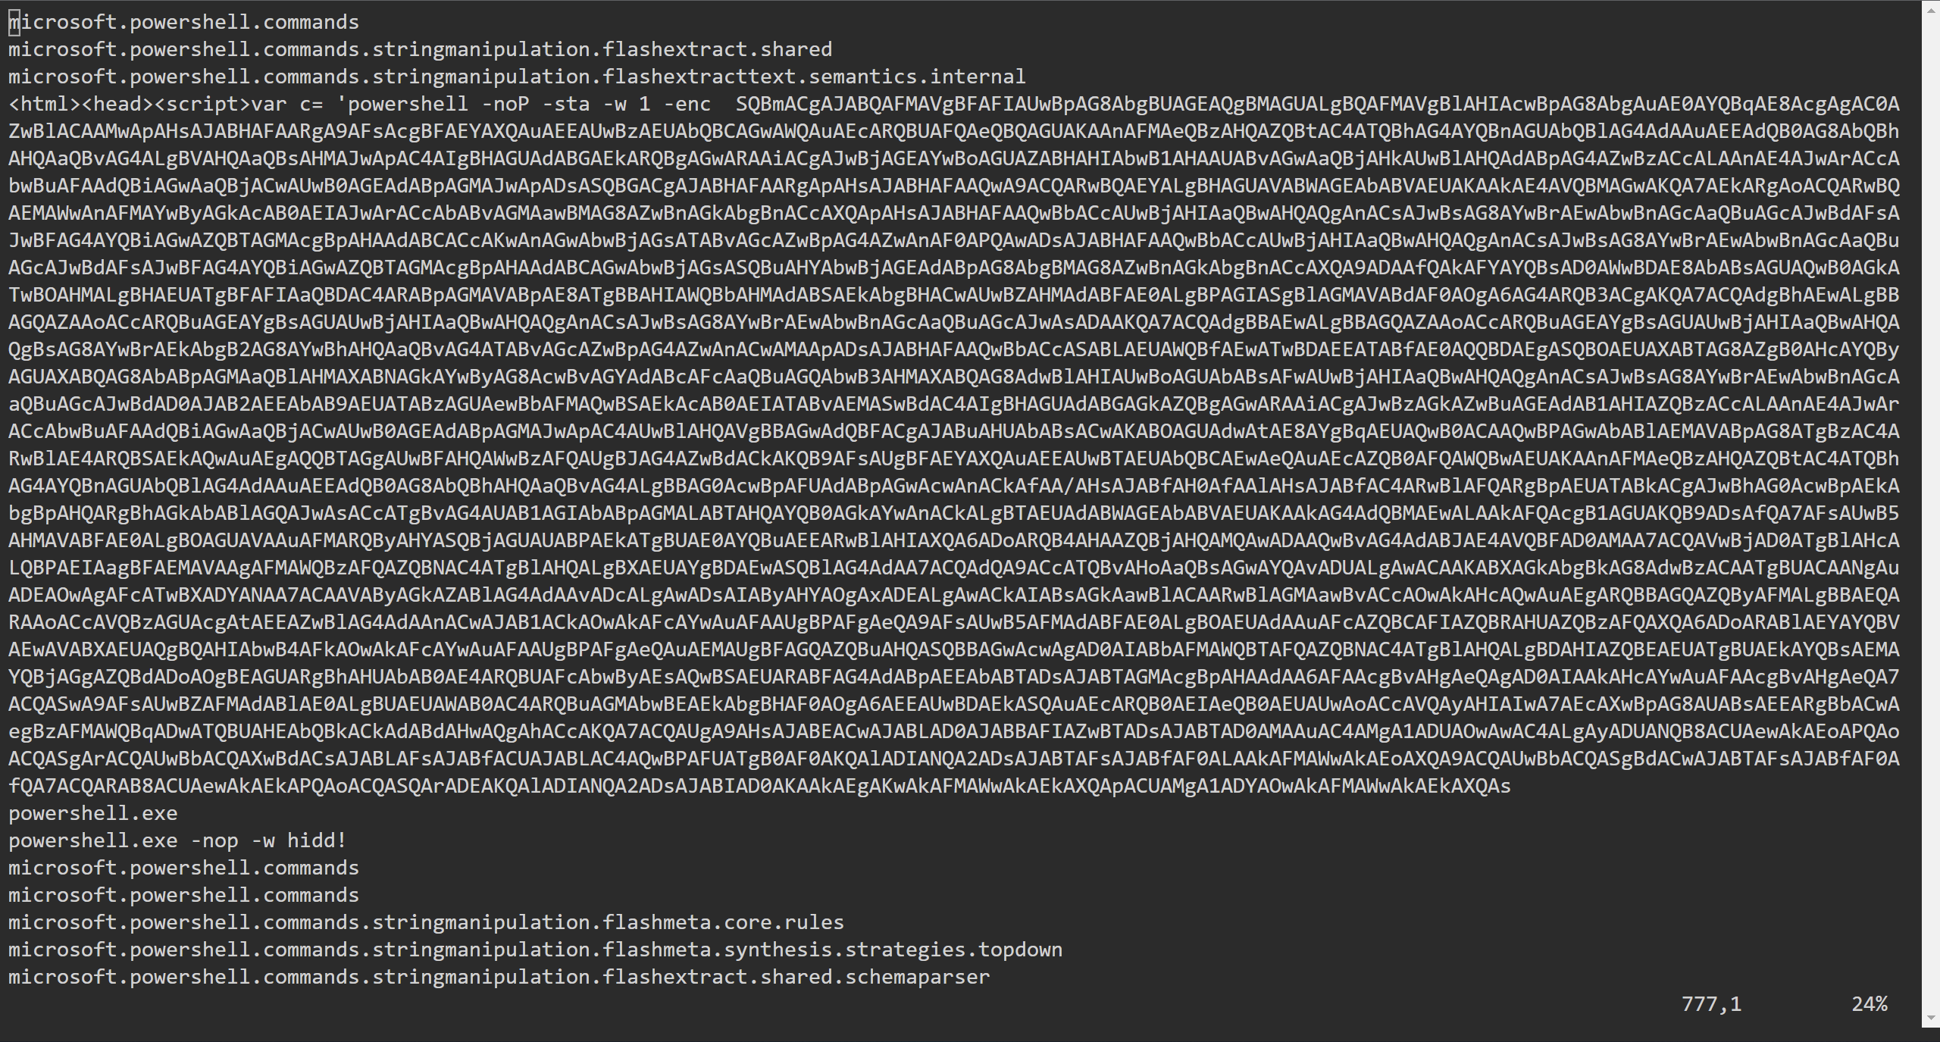
It looks like a HTA template is probably the source of compromise. Decrypting the Base64 results in:
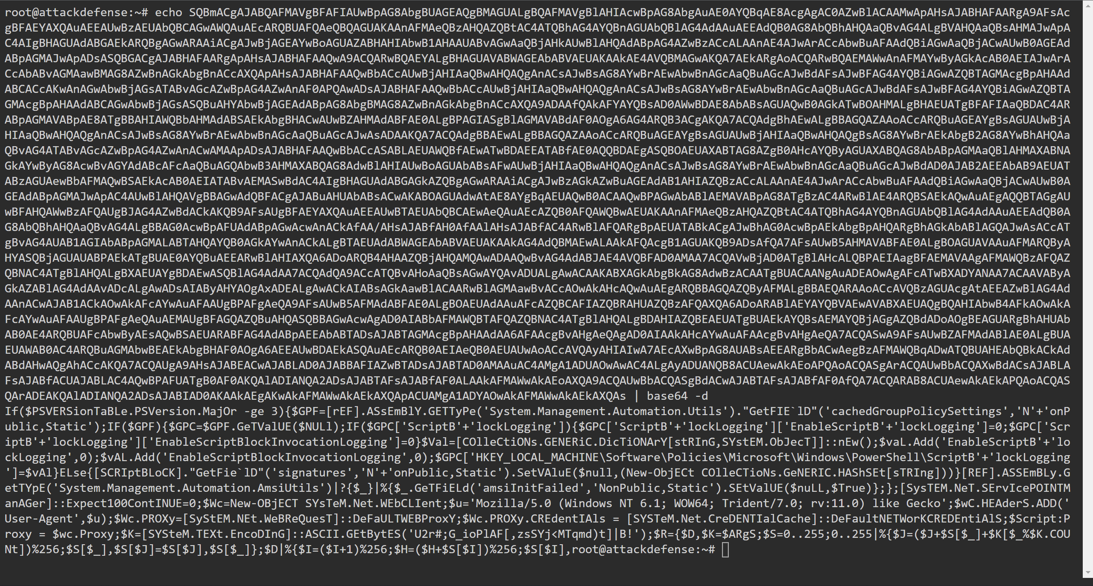
It looks like a PowerShell Empire stager, which is a firm indication that the machine was compromised.

KEY TAKEWAYS
- Volatility can display data even from terminated objects (such as network connections)
- Not all injections load a windows executable file ("MZ" header)
- The strings utility can help identify and extract patterns in memory files

